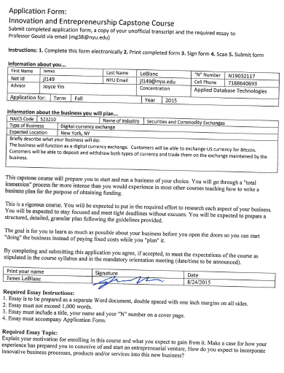

Innovation and Entrepreneurship Essay

James LeBlanc

N19032117

I enrolled in this class primarily to learn the necessary steps in building a successful business, something I have always wanted to do. I have seen a number of people start business that eventually failed. This has a given healthy appreciation of the difficulty in starting a new venture. I expect to acquire an in depth understanding of the how to design and build a new business. I recently toke a marketing class where I learned the importance market research and having a clear understanding of what you plan to sell and who you plan to sell it too. I would like to learn the next steps in building a successful business that can produce and sell the products identified in a marketing plan.

In the years I’ve been working I have been exposed to many aspects of a business. I spent time in production on a factory floor where I learned how assembly lines are setup and the importance of inventory management. I also work in customer service both as a cashier and later as a help desk specialist there I learned how important good customer relations are to a business. Recently I have working as a data engineer mostly in support of the finance department where I have learned the importance of maximizing revenue and minimizing costs.

I have spent nearly 30 years studying computers and machine language. I have extensive experience designing and building information systems. Now more than ever it is essential for businesses to harness new information technologies. My years of experience researching, evaluating and implementing new technologies will allow me to incorporate innovative business processes, products and services into my new business.

A number of family members have attempted to start their own business. Unfortunately most have failed. I hope to learn from their mistakes and build a business that will last. Over the last few years I have taken classes in financial management, project management, marketing and analysis. It is my intention to combine my personal experience; lessons learned from family started business plus my recent education and start a successful business.

